Flow Case Study Template (for the FCC Certification)

Company: <enter company name>

Value-add: <enter value add here>

Industry: <enter here>
FCC: <enter your name here>
FCT and/or authorized FCC Coach: <enter your FCT’s / authorized FCC’s name here>
If you have any questions / comments regarding this Flow Case Study Template, please reach out to me at andrew@andrewkallman.com (thanks!).

<Please highlight in yellow any and all answers that you add below (I didn’t highlight all of the questions, but I think you get the idea to highlight the other ones that I didn’t highlight). This will help me immensely in reading the document. In advance, thanks!>

Executive Summary

<Write this section last, with your summary and final thoughts on the successful project, product development and/or assignment on which you worked>

Note: FCCs (Flow Certified Coaches), as part of their certification process, select one successful project/product (current or past) that they have launched and then apply the Flow Friction Analysis along with the Individual, Team, Product (Program, Process) and Organization 4-box to fill in the details of that success (included in the template below).

The FCC candidate uses the 13 mini cases along with the SingTel example that are included in our book “Flow: Get Everyone Moving in the Right Direction...And Loving It” as reference examples when filling in the details for your case study.

This is a powerful exercise that we use in our FCC and FCT training path that moves the content of this book from the abstract and theoretical over to the street-level, battle scarred arena of real-world implementations and change management.

Part I - Flow Friction Analysis (“as is” baseline)

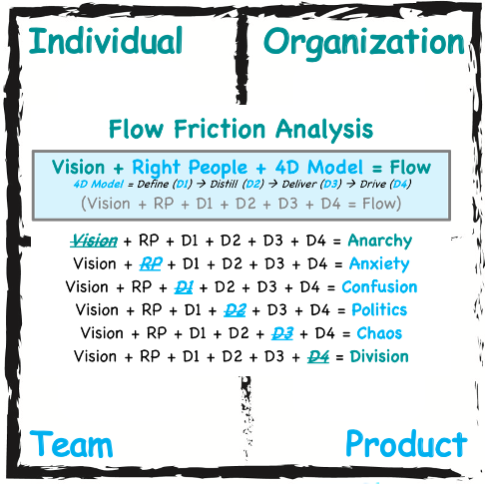

<Enter Name of assignment> had the following anti-patterns and Flow Friction items (double-click on the box to put in a “checkmark” for each one of the Flow Friction Analysis items that applies/applied to your project/work effort):

Anarchy
Anxiety
Confusion
Politics
Chaos
Division

Remember that a successful project will have had experienced Flow, as per the Flow Formula:

Vision + Right People + Definitions + Distillation (of Agreements) + Delivery + Drive (to Success) = Flow / Successful Organization. This about the “as is” starting point and the “to be” ending point of the effort. Write your thoughts here:

<fill in how & why each item you chose in the friction analysis above was present / manifesting in your team/product development/project>

Part II – The Individual-Team-Product-Organization 4-Box

Note: keep in mind that the “Product” box includes Program, Process, Line Management, etc.; and, that the “Team” box includes Project(s).

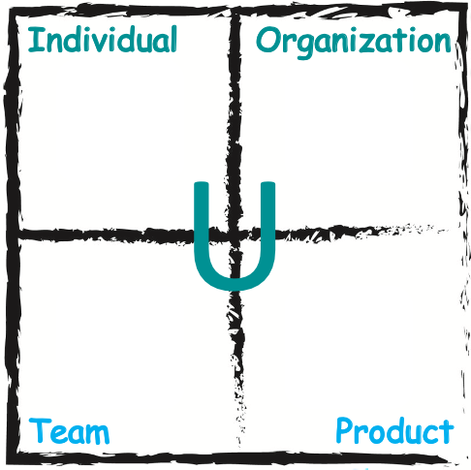

Now, fill in the details of your project / product for the “Individual-Team-Product-Organization” 4-Box:

Individual (use the 4R and 4D Models)
<share who is on your team + what is their T-shape/specialization – and this is part of the first “D” in the 4D Model below. Also, use the 4R model for each team member>

- Right Truth (Define)
  - Share each team member’s (as best as you were able to discern it) worldview or “truth” by which they lived
- Right Values & Attitudes (Distilled)
  - Did each team member display the right values & attitudes needed for the team to succeed?
    - If not, why not.
    - And, what was done to mitigate this?
- Right Actions (Deliver)
  - Did the team member behave in a consistent way?
  - Were they reliable / dependable?
  - If they let down the team along the way, what was their reaction to doing that?
  - Was the team member working on personal continuous improvement and becoming more T-shaped?
    - If not, why not.
    - And, what was done to mitigate this?
    - What did you do, specifically, to help the team member become more T-shaped?
- Right Results
  - Were all of your team members successful?
    - If not, why not?
    - And, what was done to mitigate this?

Team (use the 4D Model)
<use the 4D Model and use each “D” to describe your team>
- Who (besides the team members listed above, were there any other team members / roles that were missing in order to have a complete team)?
  - You don’t need to list everyone, again here. Only those that might have been missing from the
- When (did we start)?
- Where (was the team co-located, or distributed over multiple locations/time zones)?
- Define - Definitions
  - What was the VSPT for your team?
  - What was the size & quality of your initial backlog as a team?
  - Was the backlog growing faster than the team’s ability to deliver?
- Distillation
  - When did distillation occur (in which sprint/iteration)?
    - This usually happens when the team realizes that the initial Product Backlog they built at the training / workshop really isn’t helping them achieve their goals and/or isn’t getting them closer to delivering the Vision.
    - At that point, the team will usually begin to create NEW product backlog items.
    - When you observe these two things, then true “Distillation” has begun.
- Deliver
  - Any hiccups that you might have experienced.
  - Did the team maintain discipline throughout the sprints/iterations?
  - Did you observe any compressions, time savings, increased efficiency and/or productivity along the teams journey?
- Drive
  - Did the team focus on goals delivered?
  - Did the team keep the Vision front and center?
  - Did each review demonstrate that the team was one step closer to delivering the Vision?

Product / Program, Process, Line Management (use the 4D Model and the 4 Whys)
<use the 4D Model from a Sales, Marketing and Product Development perspective, including the 4 Whys, Strategies and tactical implementation for the product launch / roll-out>
- What (product, service, solution, result)?
- Why (are we doing this project)? Only four (4) reasons to do any project/service/result in any organization:
  - Increase Revenues
  - Save Costs
  - Mitigate or Eliminate Risk (both negative and also leverage positive)
  - Do the right thing
- Share which of these four (can be multiple) are the reasons for doing your assignment
- Define
  - What were the key product definitions?
    - Product can also mean service or result
- Distill
  - Was the customer in agreement with the definitions?
- Deliver
  - Did you consistently deliver product increments to the customer along the way during the development of the product?
- Drive
  - Was the Product Vision delivered to the customer in a way that it wasn’t just on-time, on-budget and on-scope; but, rather it was delivered in a way that your customer was delighted and said “wow”?

Organization - Executive / Portfolio (use the 4D Model, VSPT and Cascading Vision)
<Use the 4D Model, VSPT and Cascading Vision to explain how the leadership is transforming/creating the culture that will enable the organization to achieve consistent, high-performance>

- VSPT
  - Did you have a clear Vision from the Organizational leadership?
  - Did you have a clear Vision from your Department / Division?
  - Did your Portfolio have a clear Vision?
  - Did your Program have a clear Vision
  - Did your team link their Vision to all of the above listed visions?
    - If not, why not?
- Cascading Vision
  - Did the Executives clearly (and often) communicate their vision to their organization and team?
  - Did the team identify, through their retrospectives, any “one thing” feedback items (key things that if the executive did them then the team would have a higher chance of success); and, did the team then communicate those back to the Executives?
- 4D Model
  - Define
    - Did the Executives have clear Definitions for what they wanted to achieve?
  - Distill
    - Were there politics between the Executives and leaders (either horizontally or vertically)?
    - What did the team need to do to mitigate the politics and the impact on the team?
  - Deliver
    - Were the Executives and Leaders modelling the behavior?
      - Walking-the-talk vs. just talking-the-talk?
  - Drive
    - Did the leadership style and culture of the organization help or hinder the team?
    - Why?

Part III – Aha-Curve Impacts in all four parts of the “Individual-Team-Product-Organization” 4-box:
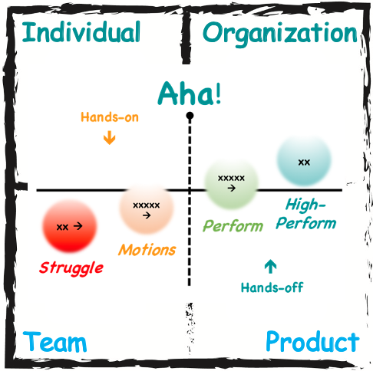

Write your thoughts here (i.e. how “Getting to Aha!” has impacted your 4-box analysis above, etc.):
<update & fill-in as needed>

- Place each team member on the above curve at the beginning of the development / assignment
  - Individuals
    - Struggling - <list each person here that was struggling>
    - Motion – <list each person here that was only going through the motions>
    - Perform – <list each person here that was performing>
    - High Perf - <list each person here that achieved a consistent, sustainable state of high performance>
  - Team-level
    - ‘Within the Room’- share if the team where the team was at in the protected environment (Struggle, Motions, Performing or High performing?)
    - ‘Outside the room’ – (Struggle, Motions, Performing or High-performing?)
  - Product (includes Program, Middle Management, etc.)
    - Struggle, Motions, Performing or High performing?
  - Organization (includes Portfolio, Executives, etc.)
    - Struggle, Motions, Performing or High performing?
- Then, do a second curve with where they were at the end (same as above, but the end state at the end of the development / assignment)
  - Individuals
    - Struggling - <list each person here that was struggling>
    - Motion – <list each person here that was only going through the motions>
    - Perform – <list each person here that was performing>
    - High Perf - <list each person here that achieved a consistent, sustainable state of high performance>
  - Team-level
    - ‘Within the Room’- share if the team where the team was at in the protected environment (Struggle, Motions, Performing or High performing?)
    - ‘Outside the room’ – (Struggle, Motions, Performing or High-performing?)
  - Product (includes Program, Middle Management, etc.)
    - Struggle, Motions, Performing or High performing?
  - Organization (includes Portfolio, Executives, etc.)
    - Struggle, Motions, Performing or High performing?

Part IV - Using the elements of the Flow Canvas

Flow Canvas – Vision/Flow Clarity

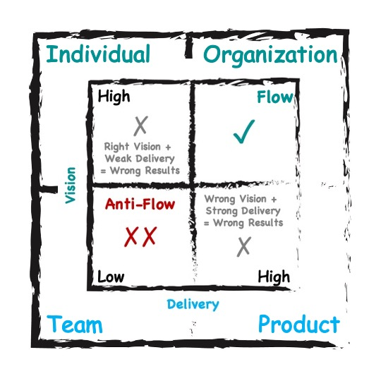

Share your thoughts on where your project was, at the beginning, using the above Vision / Flow Clarity analysis.
<share here>

- Here’s an example (edit to match your team; add other items if these don’t apply):
  - Low understanding of the tool and task at hand.
  - Our team vision was clear but did not know how it lined up with Leaderships vision.
  - Who owns the roll-out became a big issue.

Flow Canvas – Communication(s) Gap

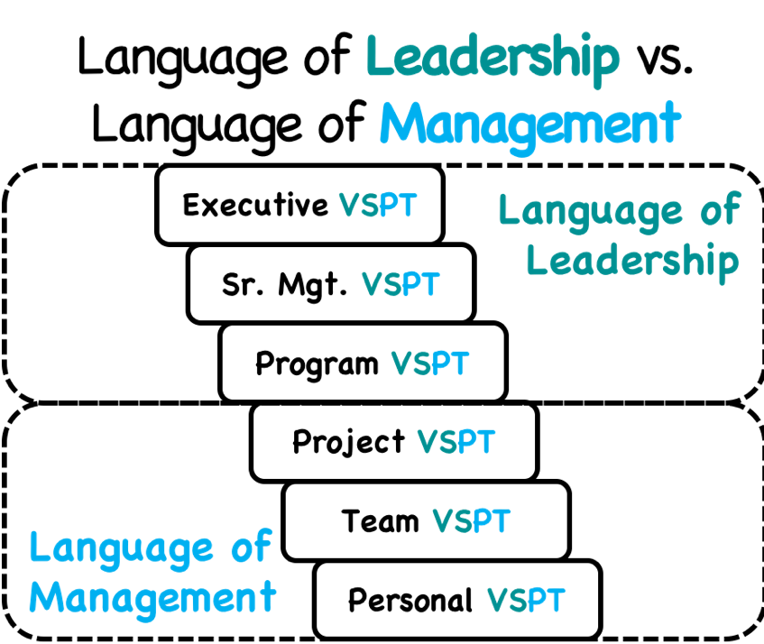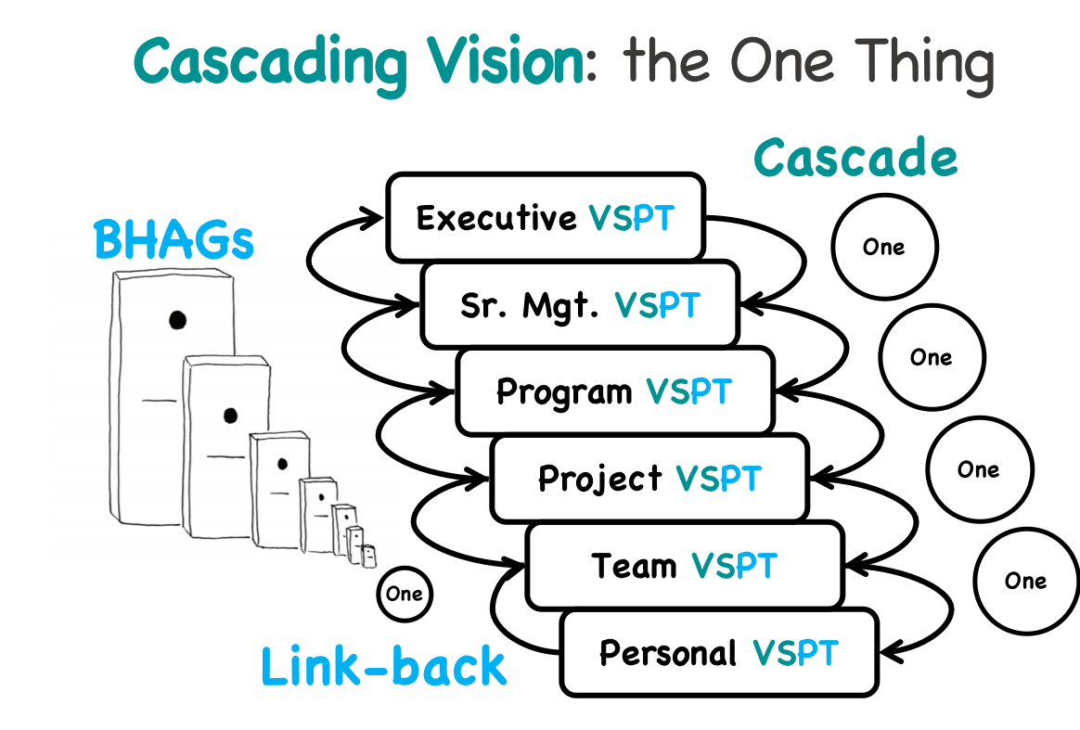

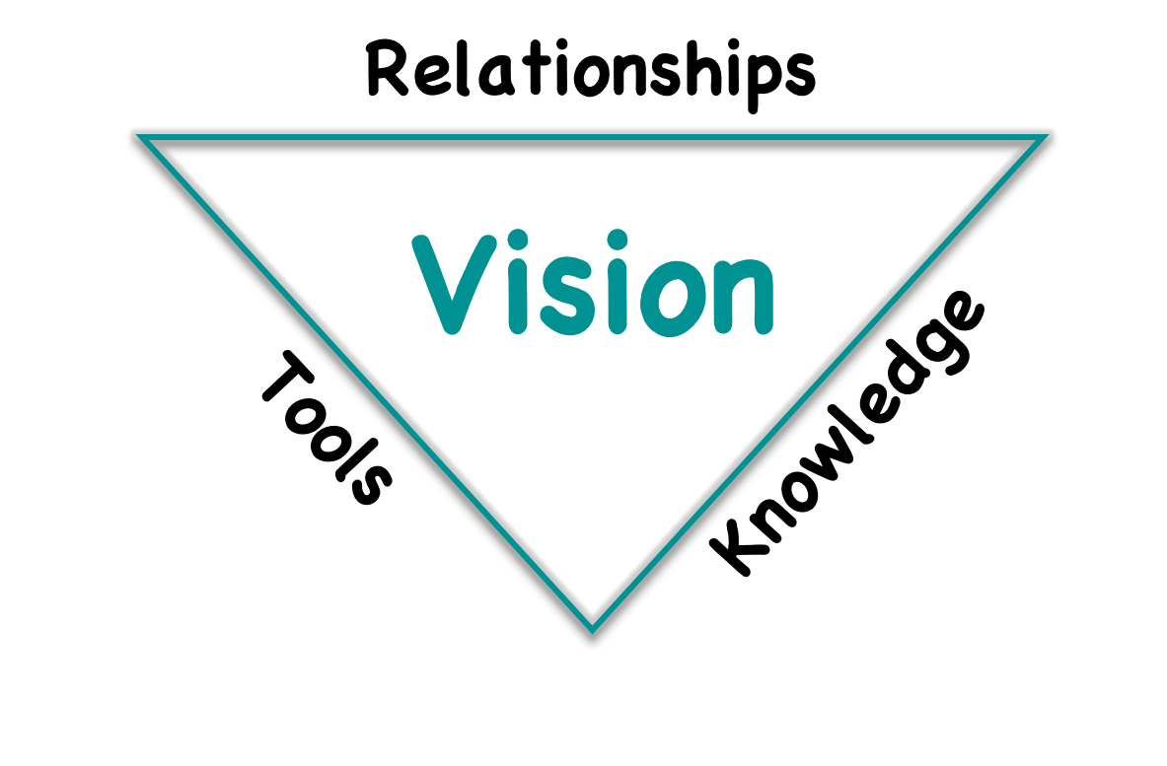

Share your strategy and tactics for bridging the communications disconnect between your team and the organization:
<Languages of Leadership/Management – share here>
<Cascading Vision, VSPT and The One Thing - share here>
<Relationship, Tools, Knowledge triangle – share here>

Flow Canvas – Stakeholder Mapping

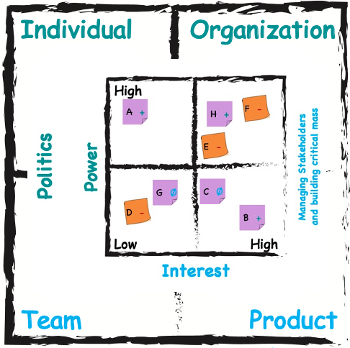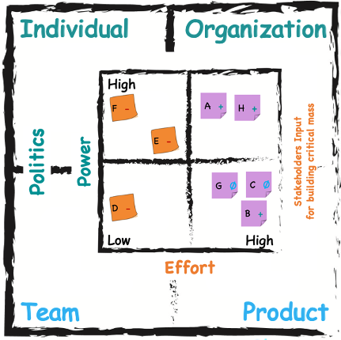

Share your thoughts on Stakeholder Management and internal campaign management. Are you stakeholders for you, individually; and, are they for your project (two separate things)?
<Share each key stakeholder here and why they are a +, - or 0 for your project – use both the effort and interest pictures above>
<include a stakeholder map like the one above>

Flow Canvas – Culture Mapping

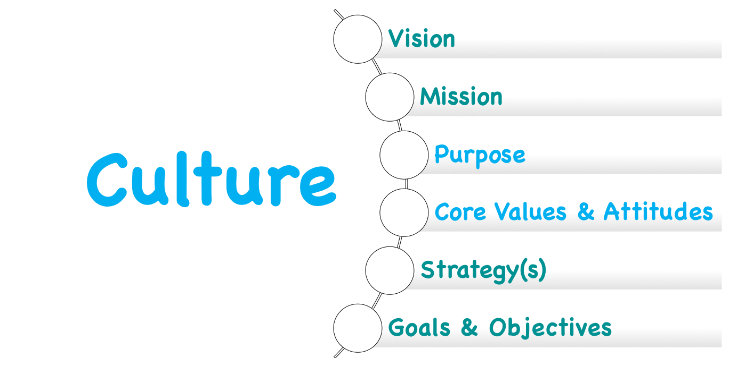

Using the Flow definition of Culture, analyze your organization using the outline above and how each of those will either enable or hinder your project’s ability to succeed.
<Share each item here>
- Vision
  - <include a copy of both your team’s Vision, your division’s Vision along with the Company Vision>
- Mission
  - <include a copy of both your team’s Mission, your division’s Mission along with the Company Mission>
- Share the Purpose for your project
- Share your Team’s Core Values & Attitudes
  - <include a copy of any team agreement(s) that exist>
- To which Strategies does your team link
- Share the Overall Goals & Objectives of your project
  - <include copies of Sprint goals>

Also, include the baseline summary team health check picture, if available. Use the above picture along with the 4D and 4R Models for additional clarification, if needed.

<Share team health check picture here, if used, if not used, insert “n/a” for this section>
<Share which item(s) need attention based on the results of the health check>
<If any of the items links to Culture, explain how Culture is either an enabler or a blocker to your team really being able to succeed>

Flow Canvas – Agile Coaching / Management Consulting

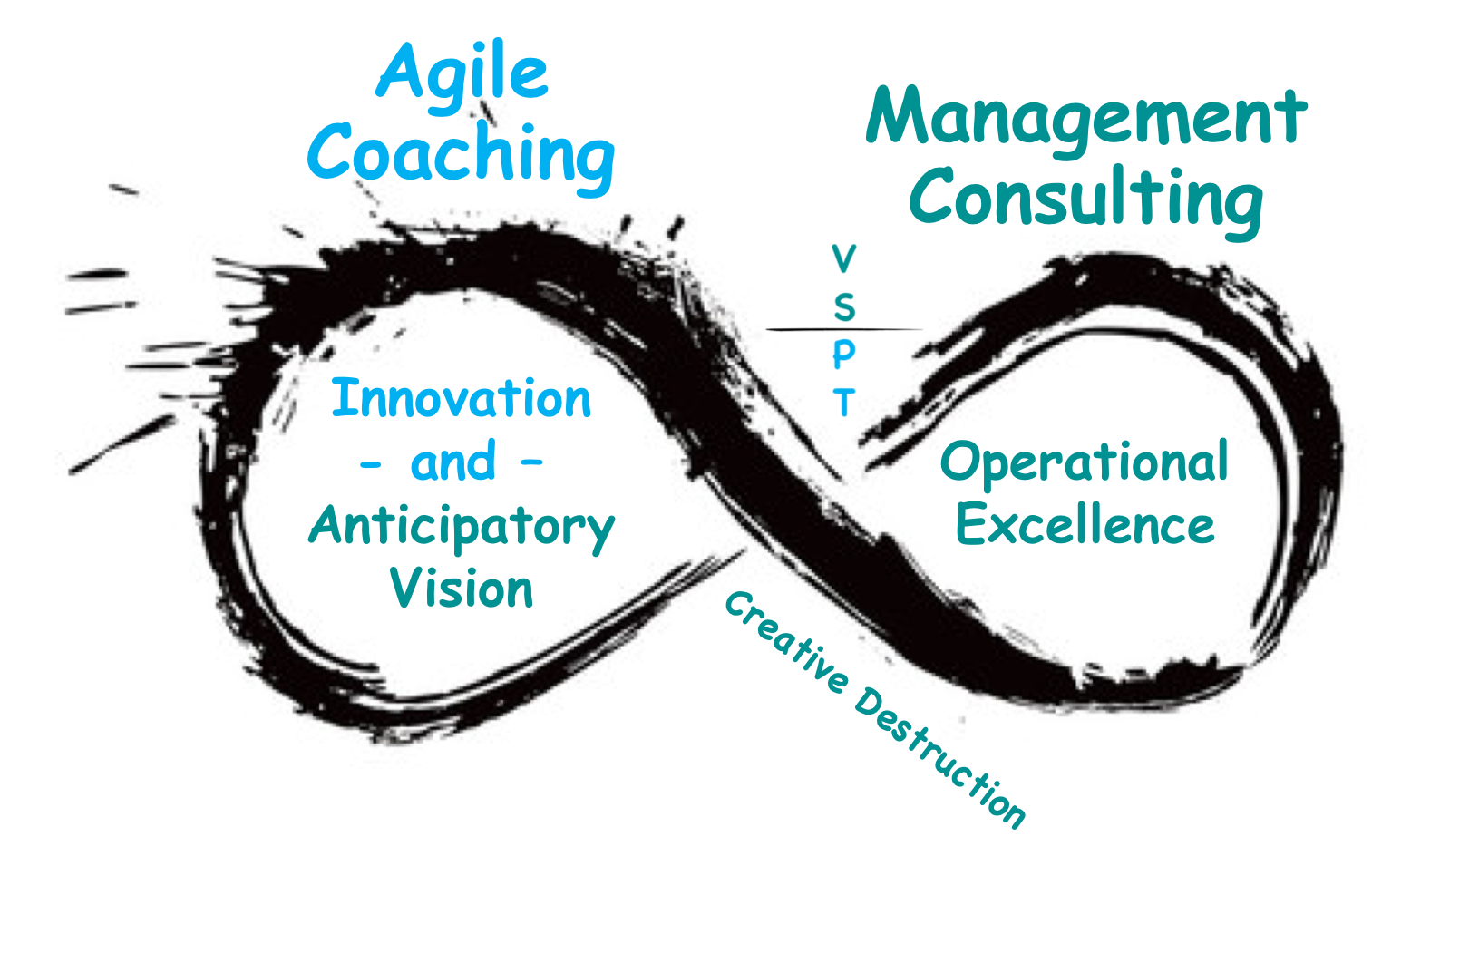
Share examples from your current project of how you have used both Agile Coaching and Management Consulting with your team(s).

<Share your examples of using both ways of working here>

Flow Canvas – Stacey Diagram

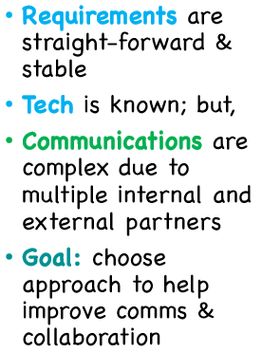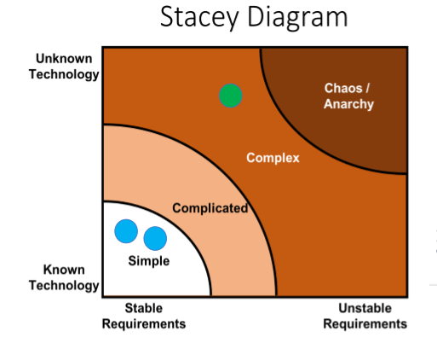

Using the Stacey diagram, chose one of the four items below and then describe at which level your project is operating?
- Simple
- Complicated
- Complex
- Chaos

Example description:

“Based on what we have seen so far, <company x> appears to be more reactive than proactive. Although, <company x> has an emphasis on innovation, but they seem to be a market follower and not a leader. <company x> is at least xx years late in adopting, doing and (ultimately) being Agile.”

Flow Canvas – Anticipatory Vision
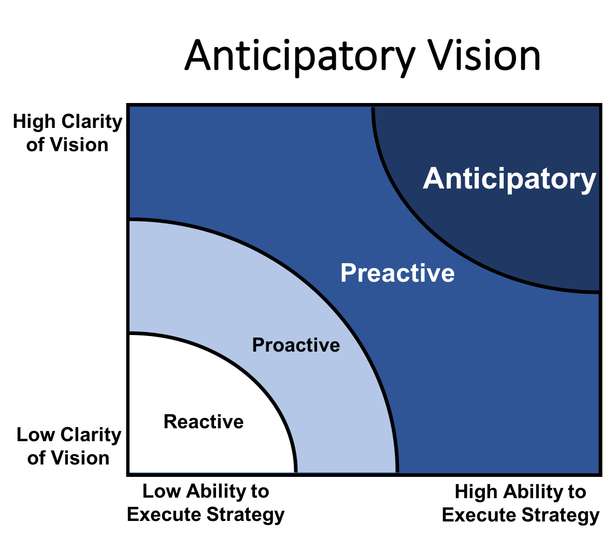

Using the Anticipatory Vision matrix, chose one of the four items below and then at which level your project is operating?
- Reactive
- Proactive
- Preactive
- Anticipatory

<Share your answer here, with your justification/motivation defending your answer – see example up in the Stacey Diagram section for thought starters>

Part V - Value-add for each project/assignment

If possible, assign in real dollars the concrete value-add your project is bringing to the table. If not measurable in actual currency, then look for ROIs using:
- Faster speed to market
- Increased revenues/sales
- Cost savings
- Decreased risk/error reduction
- Increased team velocity
- Increased speed of decision making
- Compressed timelines
- CSR-like KPIs

<Share your answer here, with your justification/motivation defending your answer>

Part VI – Final Thoughts

Your “Final Thoughts & Conclusions” should now be shared in the Executive summary at the start of this template.

Thanks, and congratulations on completing your next step in achieving the FCC!

